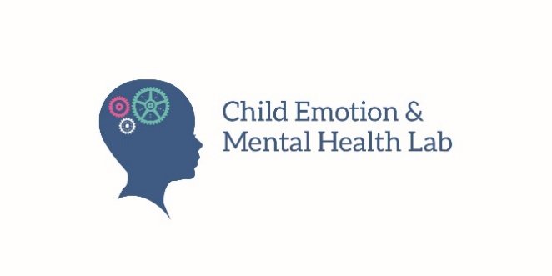

FACES
Family and Child Emotion Study
Parent Consent Form and Permission Form for Child Participation
(Home Assessment)

Your and your children’s participation is voluntary.
You and your children are under no obligation to participate in this study. You do not waive any legal rights by agreeing to take part in this study. If you choose to participate and permit your children to participate, you may change your decision at any time, without penalty or loss of benefits to which you or your children are otherwise entitled.

What will I do during this assessment?
Your family will receive wristbands to wear at home for 10 days. You, your partner, and your two participating children will complete questionnaires, participate in tasks together, and wear a wristband that gathers physiological data (sort of like a Fitbit). Your family will receive instructions and training on how to wear the wristband and how to download and use a phone app that will show you how to monitor your emotions. The four participating family members will be required to wear the wristbands at home during evenings and weekends (i.e., not during work or school), but not during exercising, bathing, and sleeping. After the 10 day period is complete, the research team will retrieve the wristbands. Any information we gather from you (e.g., questionnaires, physiological measurements) are not being employed diagnostically and do not constitute or substitute for formal diagnoses.

Will I receive any incentives for participation?
Activity | Parent | Child
Questionnaires | $20 | $5
Wristband, phone app, tasks | $50 | $15

What are the benefits to participating?
Although there are no clear, direct benefits to you or your children, you may be happy to contribute to the advancement of knowledge about family communication, emotions, and interactions.

What are the potential risks or discomforts?
Wearing the wristband could make you feel uncomfortable, and may cause some slight irritation for those with very sensitive skin.

What happens to the information you gather from me? Who will see this information?

Confidentiality: We want you to know that all of our staff are trained on how to keep your information confidential. That means that we do not share your information. All the information collected will be stored in a secure way. Members of the research team will collect names for consent purposes, and this information will be kept separate from any participant data. Collected electronic information will be stored on a secure server that is only accessible by members of the research team through individual login IDs and passwords. Please note that confidentiality cannot be guaranteed while data are in transit over the internet. All data files will be kept on a secure server that requires special permission by the University of Guelph IT team (with authorization from Dr. Thomassin). No one else will be able to access files.

Limits to confidentiality: Confidentiality does not extend to information about possible child abuse, or significant risk of harm to self or others. If one of our staff is given such information, we are required by law to take necessary actions in order to protect you, your children, or someone else from harm. This may include reporting to the principal investigator, Kristel Thomassin, and appropriate authorities, or any person who might be in danger.

Who is the research team?: At any given time, the Child Emotion and Mental Health Lab (Director: Dr. Kristel Thomassin) is comprised of various student research assistants and volunteers. All members of the research team complete research ethics training before they can participate in research activities. If at any time you want to know who is part of the research team, you can visit our website (childemotionlab.ca). This research is funded by the Social Sciences and Humanities Research Council of Canada and the Natural Sciences and Engineering Research Council of Canada.

Uses of data: All data will be kept indefinitely for data analysis purposes, and the PI will evaluate the need to keep the data every five years after completion of the study. The data will be adequately destroyed once it is no longer needed for data analysis purposes. The data will be kept for a minimum of ten years. The anonymized dataset may be made available through a public research repository. Once the data is made publicly available, you will not be able to request that your data be deleted.

What if I want to withdraw?
If you choose to withdraw from the study for any reason, you and your children are still entitled to the full compensation amount listed above. If you decide that you no longer wish to participate, no further data will be collected. However, if you would like your data to be deleted, please contact our research lab directly by emailing emotions@uoguelph.ca. You have until September 1, 2023 to withdraw your data.

Are there any conflicts of interests involved?
There are no conflicts of interests involved in this study. The researcher(s), members of the research team, and/or their partners or immediate family members will not receive any personal benefits.

Will the study be published or otherwise disseminated?
The researchers will make an effort to publish results of this study in the form of presentations/posters at conferences and papers in peer reviewed journals. Any data published or made available will be in aggregate form or completely de-identified form and will not allow for the identification of any individual participants. Additionally, data collected may be re-used in student projects or other research. The results of this study may also take the form of undergraduate and graduate theses.

Will I receive information about the results of this research?
As soon as results from the study are published, this will be noted on our website (childemotionlab.ca). You can contact us at any time to ask about or obtain copies of published research results.

What if I have questions?
If you have any questions or concerns about the research, please contact Dr. Kristel Thomassin, Ph.D., C.Psych., at Kristel.Thomassin@uoguelph.ca. If you have questions regarding your rights and welfare as a research participant in this study (REB# 19-07-018) please contact: Manager, Research Ethics; University of Guelph; reb@uoguelph.ca; (519) 824-4120 (ext. 56606)

Wellbeing resources in Guelph-Wellington Area:
• Family Counselling and Support Services - 519-824-2431
• Couple and Family Therapy Centre, University of Guelph - 519-824-4120, ext. 56426
• Here 24/7 Helpline - 519-824-4120, ext. 56426

I have read the information provided for the study as described herein. I sign this form (OR give my video-recorded verbal acknowledgement) to indicate that I give consent for me and my children to participate in this study. Please keep a copy of this consent form for your records.

_____________________________________________________
Name of Child of Participant (Please Print) Date

_____________________________________________________
Name of Child of Participant (Please Print) Date

_____________________________________________________
Name of Parent Participant (Please Print) Date
_____________________________________________________
Name of Parent Participant (Please Print) Date

________________________________________________________________________________________
Parent Participant Signature Date

________________________________________________________________________________________
Parent Participant Signature Date

